EXERCISE 2
PING
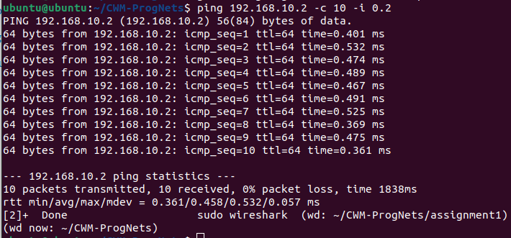
PC to pi, c=10, i =0.2
pi to PC, c=10, I =0.2
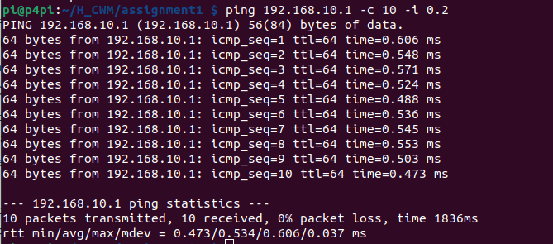

pi to PC, c=100, i=0.001

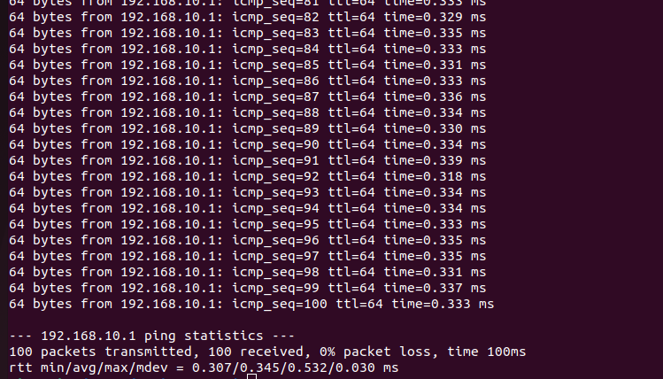
The mean is quite close to the minimum comparative to the maximum, suggesting a consistent ping with the odd high value.

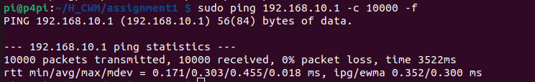
pi to PC, c =10 000, flooding
0.01/0.001/0.0001s ping.log values

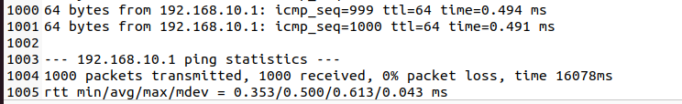
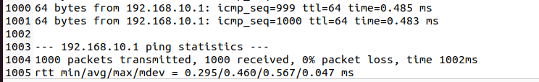
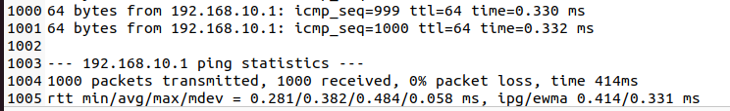

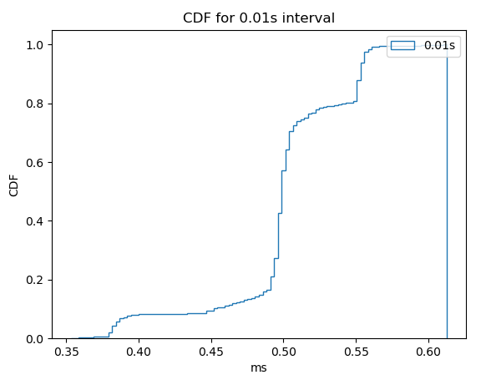
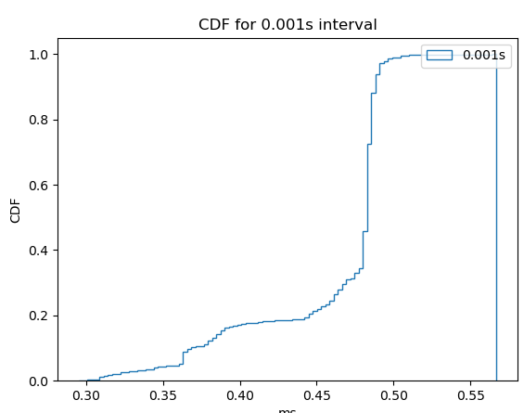
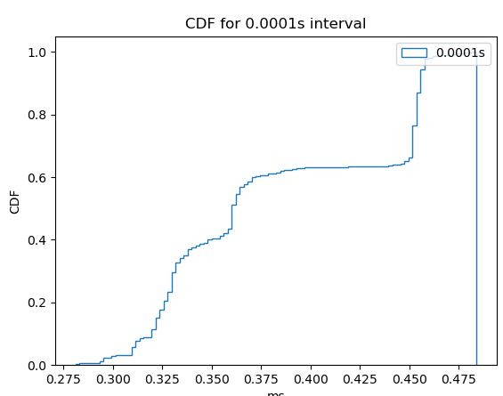

Intervals cannot actually affect the latency between the devices, and yet the discrepancy is seen above: lower interval leads to lower ping on average. The likely explanation for this is something to do with the way the RTT is measured, rather than the RTT itself.

Mean ping is likely the most useful value, as it gives a good estimate of what a future packet’s journey will last based on a higher statistical backing.

IPERF

PC to pi, t=20, TCP
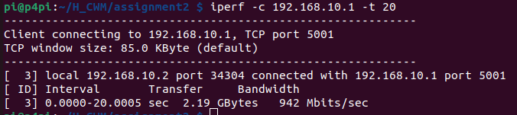
pi to PC, t = 20, i = 1, TCP
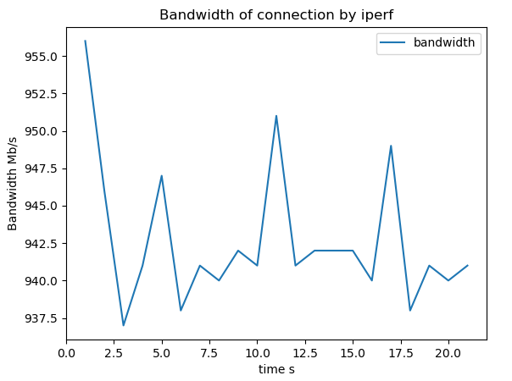

pi to PC, t = 10, I = 1, TCP, bi-directional

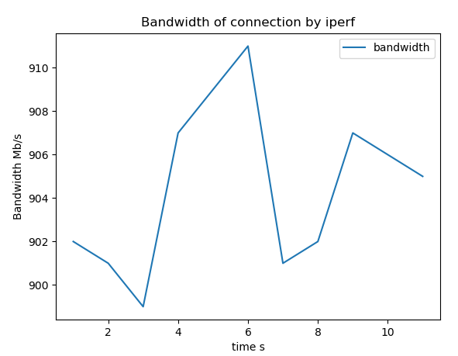
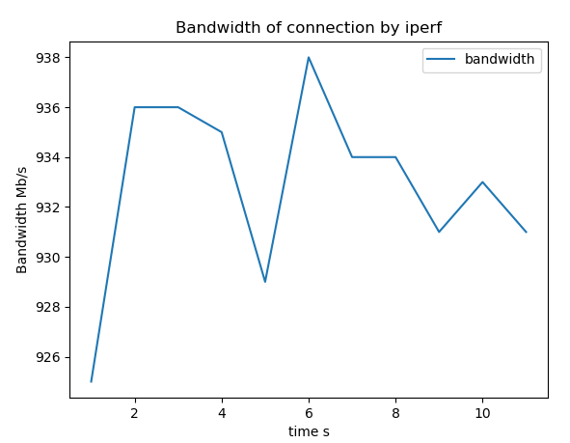

PC to pi, t = 5, UDP (0.1, 1, 100 MBit/s)

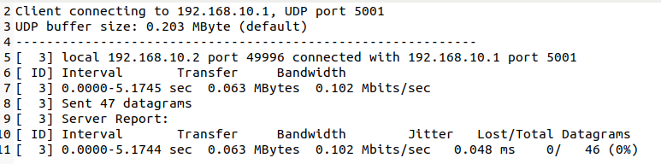
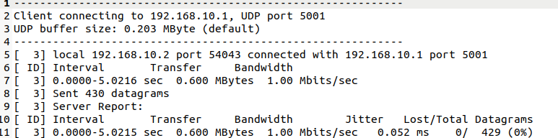
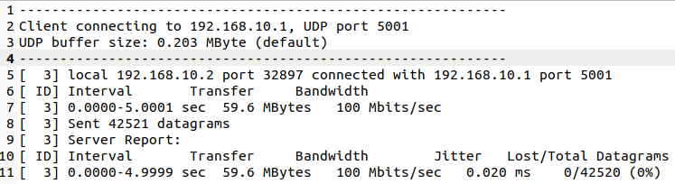

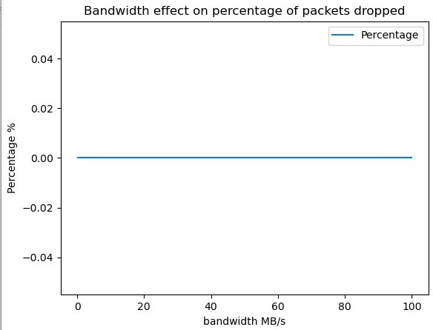
IPERF3

pi to PC, t = 10, i = 1, TCP

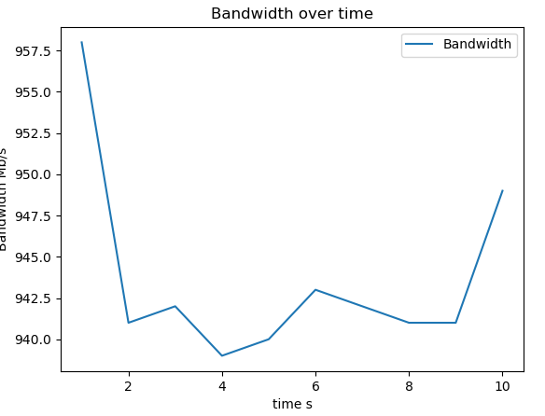

PC to pi, t = 5, UDP (0.1, 1, 100 Mb/s)

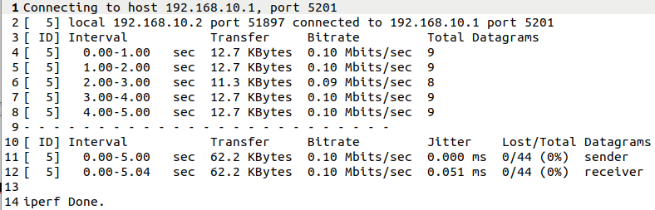
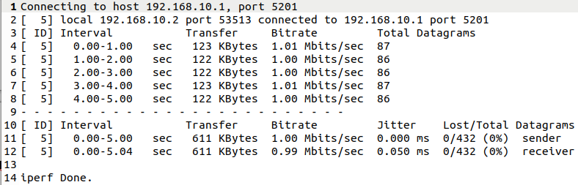
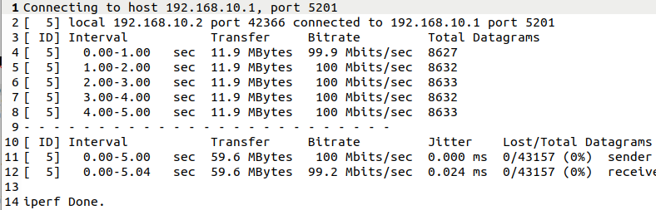

The graph is exactly the same, with no packets dropped for any of the configurations. It is possible that the connection is far exceeding expectations, those being presumably to find that iperf should have a higher loss than iperf3 if the bandwidth was high enough, which it doesn’t seem to be.

Repo here (but probably not very useful): https://github.com/Hamozwa/CWM-ProgNets

